**Predicting house prices using machine learning**

* The machine learning model is given the test data but without the price of the properties in order to predict the price for them given the various features for the properties. The predicted price is then compared to the actual price in the test data.

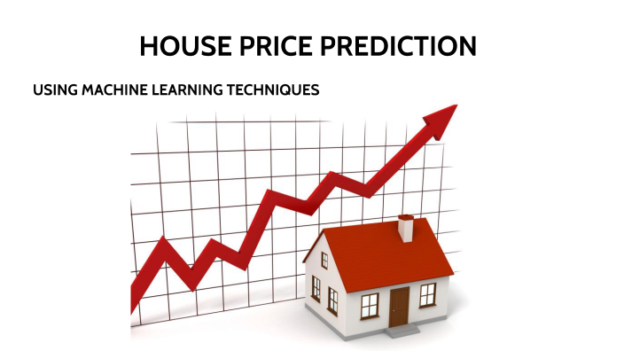

**Economy of the country is greatly driven by the prices of houses in that country. Both buyers and sellers depend on the pricing strategies. Ask an emptor to explain the factors they think are considered for pricing the house at that price and that they probably start with railways and end with various attributes. Over here it proves that more factors will be applied on the pricing strategies of the house. The aim of the project is to predict the house prices with various regression models. Nowadays Machine Learning is a booming technology. Data is the heart of Machine Learning. AI and Machine Learning holds the key position in the technological market. All industries are moving towards automation. So we have considered ML as a main predicting subject in our project and worked using it. These days everything fluctuates. Starting with crypto and various business models varies day by day which includes real estate as well so in this project house prediction depends on real estate data and ML techniques. Many people want to buy a good house within the budget. But the disadvantage is that the present system doesn’t calculate the house predictions so well and end up in loss of money. So, the goal of our project is to reduce money loss and buy good house. Many factors are there to be considered in order to predict the house price which includes budget factors and fewer house modifications according to the buyer. So, we are considering all of those factors and predicted using various machine learning techniques like SVR, KNN, SGB regression, CatBoost regression, Random forest regression**

TENSORFLOW &KERAS-ANN

1. **Import Libraries**:

**First, you need to import TensorFlow and other necessary libraries.**

**python**

**import tensorflow as tf**

**from tensorflow import keras**

1. **Data Preparation**:

**Load and preprocess your dataset. This may include tasks such as data normalization, splitting data into training and testing sets, and one-hot encoding for categorical variables.**

1. **Build the Model**:

**In Keras, you can create a neural network model using the Sequential API. This API allows you to build a model layer by layer.**

**Python**

**model = keras.Sequential()**

**Add layers to your model, including input, hidden, and output layers. Here's an example with a simple feedforward neural network:**

**Python**

**model.add(keras.layers.Input(shape=input_shape))**

**model.add(keras.layers.Dense(128, activation='relu'))**

**model.add(keras.layers.Dense(64, activation='relu'))**

**model.add(keras.layers.Dense(output_shape, activation='linear'))**

* **IBM Cloud & Watson AI Services**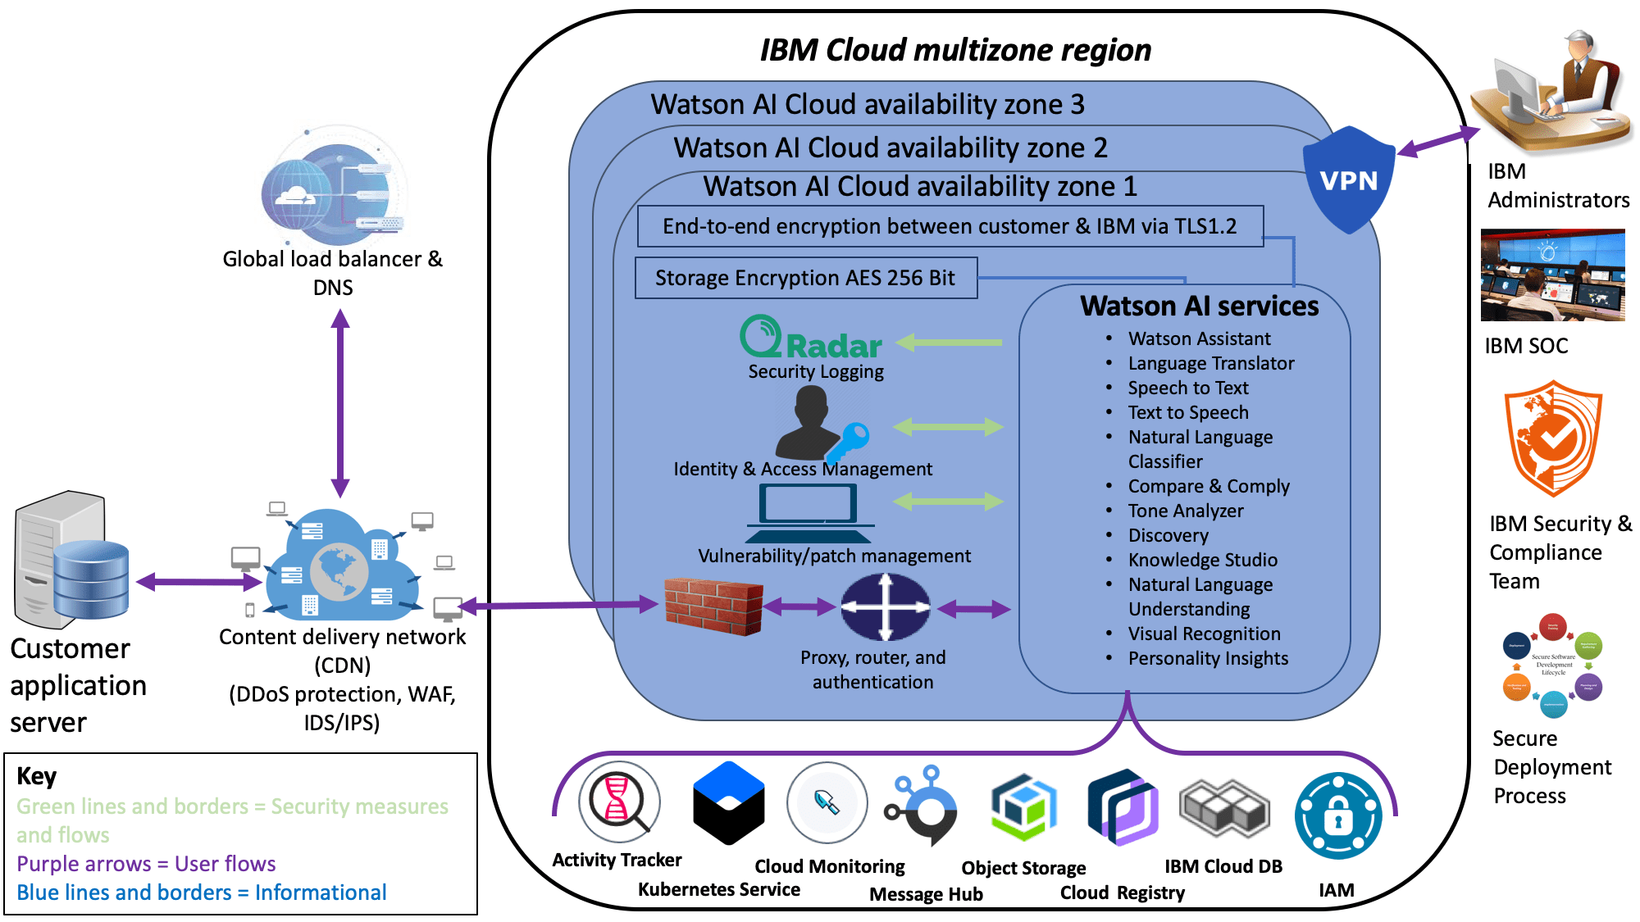
* **IBM Cloud and Watson AI Services are part of IBM's cloud computing and artificial intelligence offerings. These services provide a wide range of cloud-based tools and technologies to help businesses and developers build, deploy, and manage AI-powered applications and solutions. Here are some key aspects of IBM Cloud and Watson AI Services.**

**1.CLOUD INFRASTRUCTUER:**

Cloud infrastructure refers to the components and elements that are required to provide cloud computing. This includes computing power, networking, storage, and an interface that enables users to access virtualized resources.

**2.** **Watson AI**:

Inventing what's next IBM is developing software and hardware to bring frictionless, cloud-native development and use of foundation models to enterprise AI.

**3.AI Models**:

IBM Watson provides pre-trained AI models that can be used to develop applications for various domains, such as healthcare, finance, and customer service.

**4.Machine Learning**

IBM Cloud and Watson offer machine learning tools and services that enable data scientists and developers to build and deploy machine learning models. This includes IBM Watson Machine Learning.

**5.DATA ANALYTICS:**

 Data analytics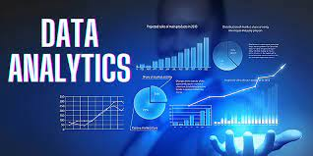 converts raw data into actionable insights. It includes a range of tools, technologies, and processes used to find trends and solve problems by using data. Data analytics can shape business processes, improve decision-making, and foster business growth.

**6.Blockchain:**

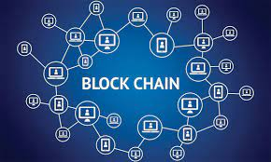

A blockchain is a distributed database or ledger [shared among a computer network](https://www.investopedia.com/terms/f/ftp-file-transfer-protocol.asp)'s nodes. They are best known for their crucial role in cryptocurrency systems for maintaining a secure and decentralized record of transactions, but they are not limited to cryptocurrency uses. Blockchains can be used to make data in any industry immutable—the term used to describe the inability to be altered.

**7.IoT (Internet of Things)**:



The Internet of Things (IoT) describes the network of physical objects—“things”—that are embedded with sensors, software, and other technologies for the purpose of connecting and exchanging data with other devices and systems over the internet. These devices range from ordinary household objects to sophisticated industrial tools. With more than 7 billion connected IoT devices today, experts are expecting this number to grow to 10 billion by 2020 and 22 billion by 2025. Oracle has a network of [device partners](https://cloudmarketplace.oracle.com/marketplace/en_US/homePage.jspx).

* **Build & Deploy ML Application**
* Building and deploying a Machine Learning (ML) application involves several steps and can vary depending on your specific requirements, but here's a general outline of the process:

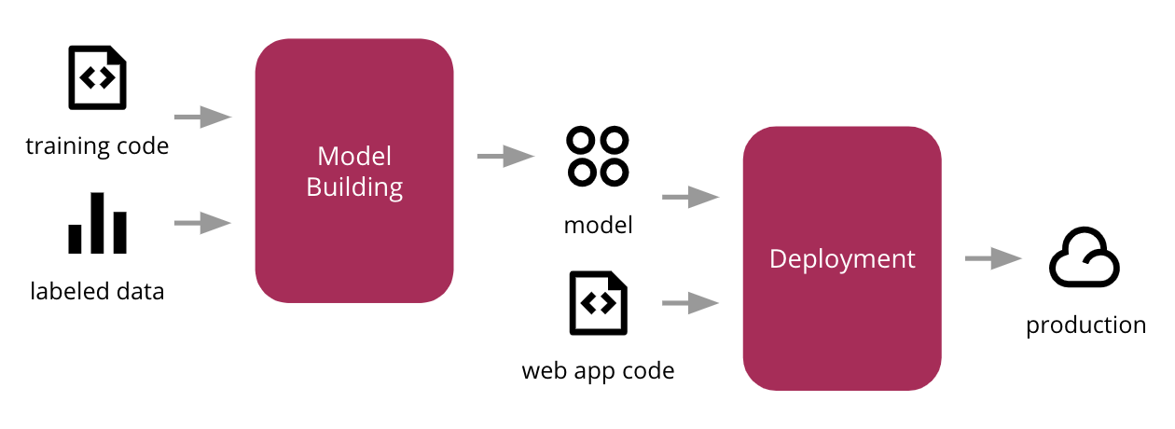

**1.Define Your Problem Statement:**

Process improvement projects are used by many businesses and organizations to make improvements in the way they operate. Several things are important to a successful process improvement project, but every project begins with identifying the problem that needs to be resolved. Understanding what a problem statement is and how to write one can help you become more successful when working on process improvement projects.

2. **Data Collection and Preprocessing:**

Concepts and techniques in preparing **data** for use in machine learning models and deep learning. Designed for mobile application developers.

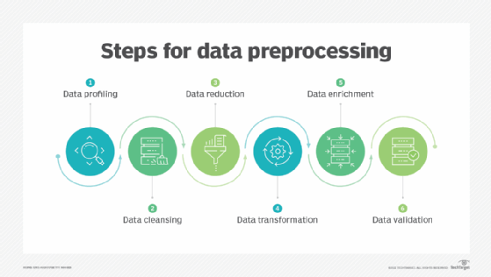

**3.Select an ML Algorithm**

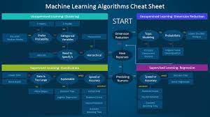

Different machine learning algorithms search for different trends and patterns. One algorithm isn't the best across all data sets or for all use cases. To find the best solution, you need to conduct many experiments, evaluate machine learning algorithms, and tune their hyperparameters.

1. **Feature Engineering:**

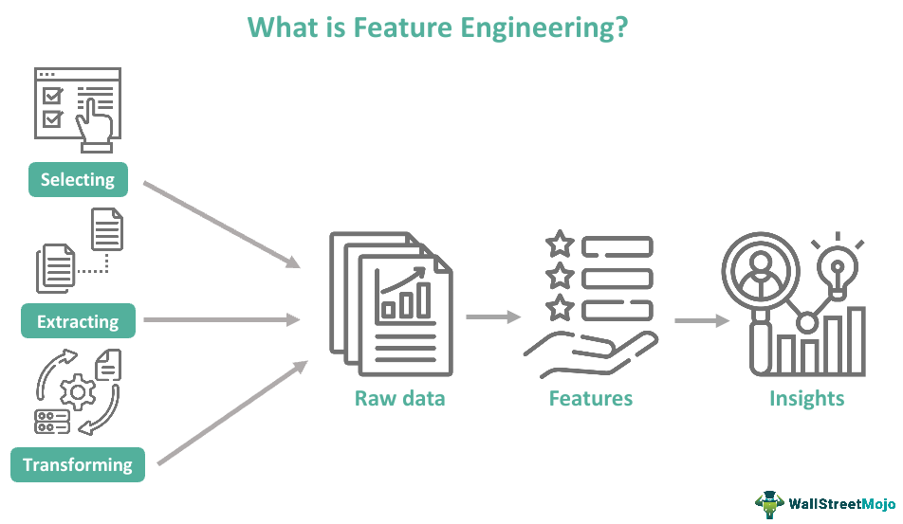

Feature engineering refers to the process of using domain knowledge to select and transform the most relevant variables from raw data when creating a predictive model using machine learning or statistical modeling.